Steps to download and install the Eclipse IDE
First you need to go to your web browser then search Eclipse Download in search bar and go to the first link.
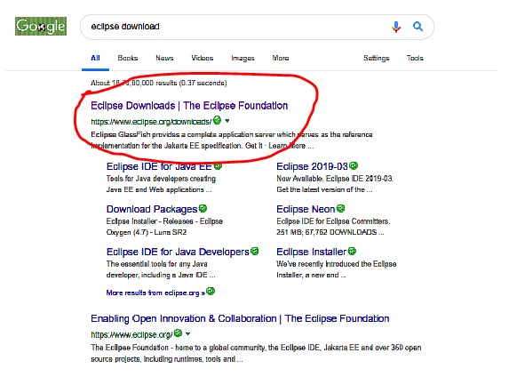
One download page will open just click on Download.
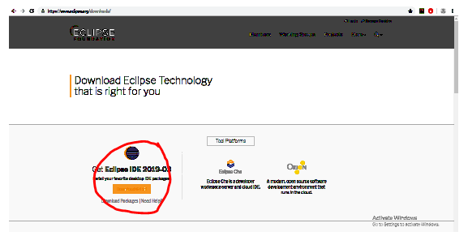
Then again click on Download.
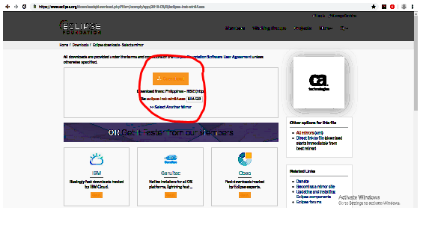
Double click on the downloaded file which is present in your downloaded folder.
Click on the Eclipse IDE for java Developers. Then click on Install.
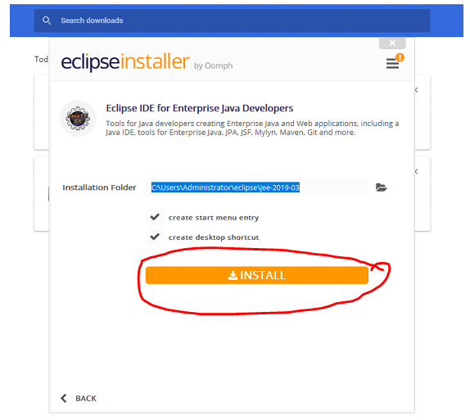

Click on Accept when licenses page come.
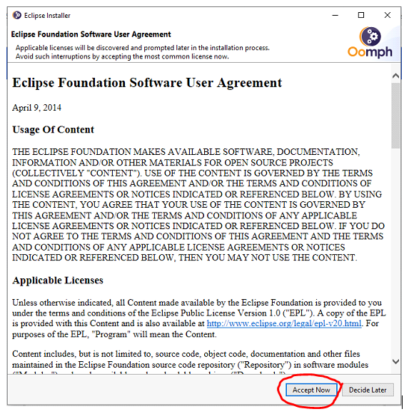
After that your installation process will start. Wait until the process is done.
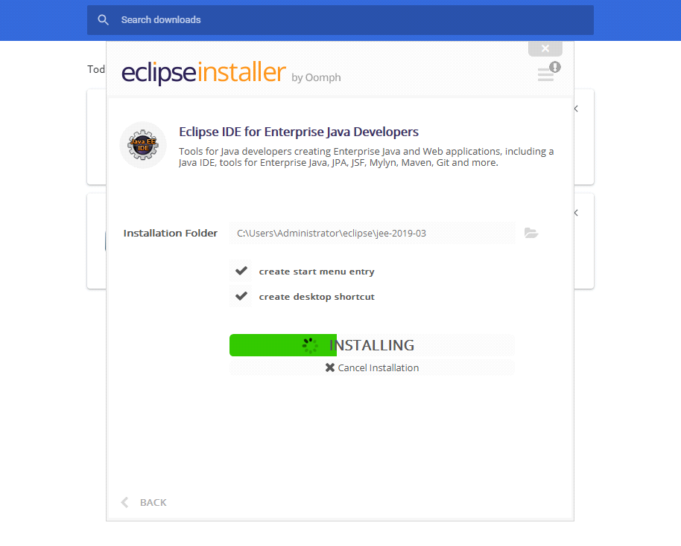
Eclipse is successfully installed on your computer. Open the Eclipse IDE. Browse and select the workspace where you want to save the file. Click on the Ok button.
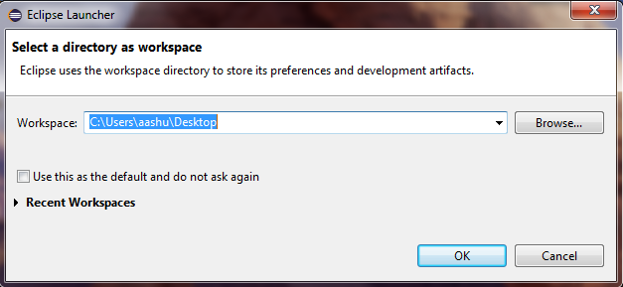
Open the Workbench.
